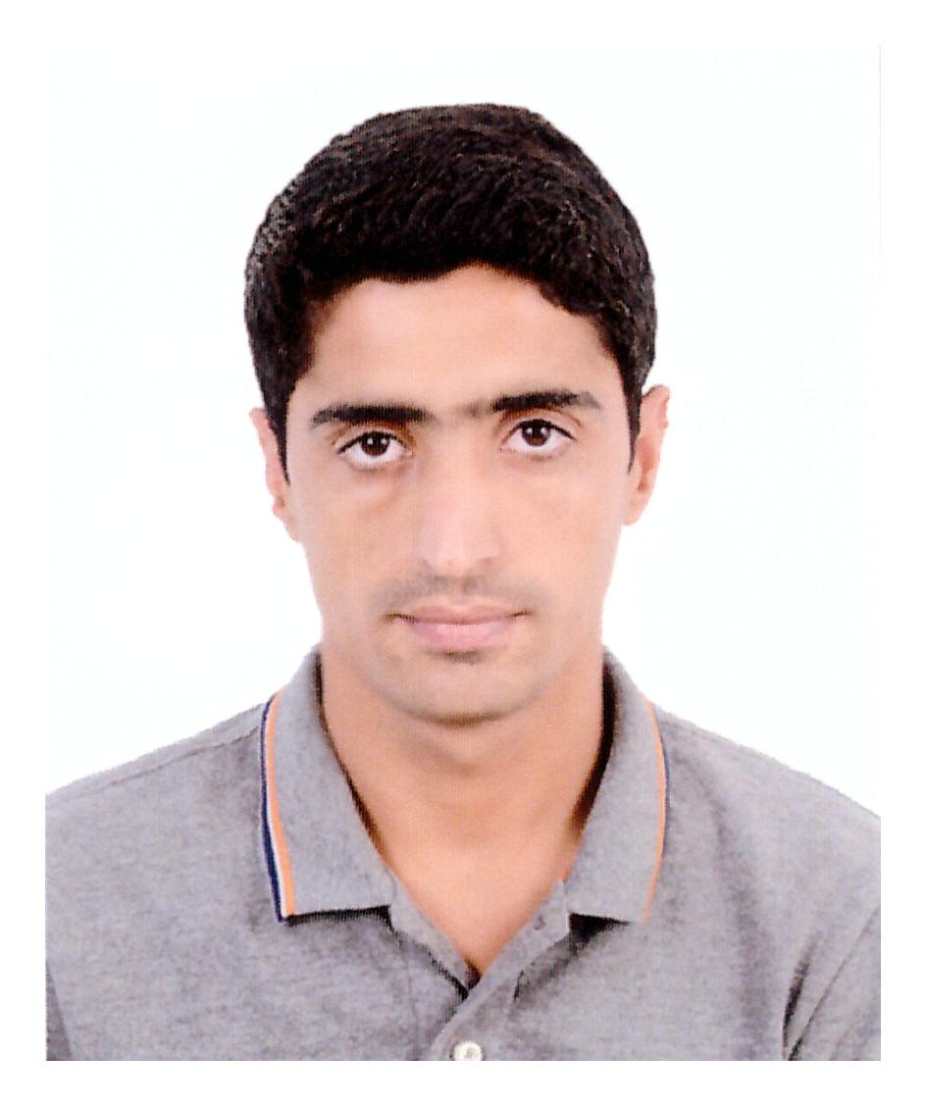

**Jalal Abdulla Mohamed**

**Mobile: 34394326  
E-mail:** [**warrnabaloch@gmail.com**](mailto:warrnabaloch@gmail.com)

Busaiteen, Muharaq

Kingdom of Bahrain.

|  |
| --- |
| Career Objective |

To obtain a respectable and a suitable position in any field, which could suit my qualifications and would help me in gaining experience and would nourish my skills. In addition, to serve the organization to the best of my skills and grow along with the organization and aspire to reach new levels of excellence.

|  |
| --- |
| Academic Record |

* HSSC, Balochistan Board, Quetta, Pakistan (2019)
* Certified MS OFFICE 2016 Specialist (From, Regal Gulf Training Center, 2019)
* SSC, Balochistan Board, Quetta , Pakistan [2017]
* Diploma in AIR FARES AND TICKETING
* GDS Software: Sabre, Amadeus

|  |
| --- |
| Computer Skills |

* A considerable Knowledge of Adobe Photoshop.
* Operating System: Microsoft Windows 7, XP
* Practical experience to do search on all topics on internet, so can easily work on internet application regarding mail and search.

|  |
| --- |
| Work Experience |

* **Dispatcher in Texas Chicken, from 1st August to 23rd September 2018**
* **Receptionist, Sky & Britco service Centre, 1st Oct 2017 to 30 July 2018**
* Collect the devices from the customer.
* Handle the warranty and non-warranty service customers.
* Convince the customers about the complaints.
* Attend the customer queries and doubts directly and telephonically.
* Call to customers for any estimation approval, collection, delivery.
* Prepare the Daily/Monthly/ performance and report to Manager.

|  |
| --- |
| Skills |

* Good customer service orientation.
* Positive work attitude.
* Ability to establish and manage relationship.
* Well disciplined, responsible and punctual.

|  |
| --- |
| Languages |

* English (spoken & written),
* Arabic (spoken & written),
* Urdu (spoken & written),
* Hindi (Spoken)
* Baluchi (spoken & written).

|  |
| --- |
| Personal Information |

Nationality: Bahraini

D.O.B: 05-03-2000

Contact: 34394326

Valid Driving License

E-mail: warrnabaloch@gmail.com

Reference will be furnished on demand.